|  |
| --- |
| AIC, MATHEMATICS LEARNING AREA  **YEAR 11 MATHEMATICS APPLICATIONS – UNIT 2**  **Assessment type: Response**  **TASK 6 – TEST 4** |

Student Name: ____________________ ID: __________ Date: 8/6/2022

**TIME ALLOWED FOR THIS PAPER**

**Reading and Working time for this paper: 50 minutes in class under test conditions**

**MATERIAL REQUIRED FOR THIS PAPER**

*TO BE PROVIDED BY THE SUPERVISOR*

Question/answer booklet.

*TO BE PROVIDED BY THE CANDIDATE*

*Standard Items:* pens, pencils, pencil sharpener, highlighter, eraser, ruler, drawing templates

**IMPORTANT NOTE TO CANDIDATES**

No other items may be taken into the examination room. It is **your** responsibility to ensure that you do not have any unauthorised notes or other items of a non-personal nature in the examination room. If you have any unauthorised material with you, hand it to the supervisor **before** reading any further.

**Structure of this paper**

|  |  |  |  |  |
| --- | --- | --- | --- | --- |
| Section | Number of questions available | Number of questions to be attempted | Suggested working time (minutes) | Marks available |
| **Calculator Assumed** | **7** | **7** | **50** | **43** |
|  | | | **Marks available:** |  |
| **Task Weighting** | 7% |

**Instructions to candidates**

* The rules for the conduct of this examination are detailed in the booklet *WACE* *Examinations Handbook*. Sitting this examination implies that you agree to abide by these rules.
* Answer the questions in the spaces provided.
* Spare answer pages can be used. If you need to use them, indicate in the original answer space where the answer is continued.

### SCSA Content – Topic 2.1 Univariate data analysis and the statistical investigation process

**The statistical investigation process**

2.1.1 review the statistical investigation process; identifying a problem and posing a statistical question, collecting or obtaining data, analysing the data, interpreting and communicating the results

**Making sense of data relating to a single statistical variable**

2.1.2 classify a categorical variable as ordinal, such as income level (high, medium, low) or nominal, such as place of birth (Australia, overseas); use tables/bar charts to organise and display data

2.1.3 classify a numerical variable as discrete, such as the number of rooms in a house, or continuous, such as the temperature in degrees Celsius

2.1.4 with the aid of an appropriate graphical display (chosen from dot plot, stem plot, bar chart or histogram), describe the distribution of a numerical data set in terms of modality (uni or multimodal), shape (symmetric versus positively or negatively skewed), location and spread and outliers, and interpret this information in the context of the data

2.1.5 determine the mean and standard deviation of a data set using technology and use these statistics as measures of location and spread of a data distribution, being aware of their limitations

2.1.6 use the number of deviations from the mean (standard scores) to describe deviations from the mean in normally distributed data sets

**Univariate data analysis and the statistical investigation process. Comparing data for a numerical variable across two or more groups**

2.1.8 use the 68%, 95%, 99.7% rule for data one, two and three standard deviations from the mean in practical situations

2.1.9 calculate probabilities for normal distributions with known mean and standard deviation in practical situations

2.1.10 construct and use parallel box plots (including the use of the ‘Q1 – 1.5 x IQR’ and ‘Q3 + 1.5 x IQR’ criteria for identifying possible outliers) to compare groups in terms of location (median), spread (IQR and range) and outliers, and interpret and communicate the differences observed in the context of the data

2.1.11 compare groups on a single numerical variable using medians, means, IQRs, ranges or standard deviations, and as appropriate; interpret the differences observed in the context of the data and report the findings in a systematic and concise manner

2.1.12 implement the statistical investigation process to answer questions that involve comparing the data for a numerical variable across two or more groups; for example, are Year 11 students the fittest in the school?

**TO BE AWARDED FULL MARKS ALL WORKING OUT AND CALCULATIONS MUST BE SHOWN**

Question 1 (5 marks)

The number of daily absentees at a small school over $15$ consecutive days are listed below:

$$7, 6, 4, 5, 6, 6, 3, 9, 7, 6, 7, 6, 4, 5, 4.$$

Using the data set above, construct a box-plot on the scale below.



Question 2 (4 marks)

State whether the following type of data is Discrete, Continuous, Nominal or Ordinal.

(a) The mass of strawberries in a basket. (1 mark)

(b) The quality rating of hotels in Perth. (1 mark)

(c) The number of computers in a classroom. (1 mark)

(d) The colour of cars in a shopping centre car park. (1 mark)

Question 3 (8 marks)

A hydroponic grower was trialling two different greenhouse systems for growing tomatoes. To compare the systems, the weight of tomatoes produced by each plant in the two greenhouses were recorded. The data is summarised below.

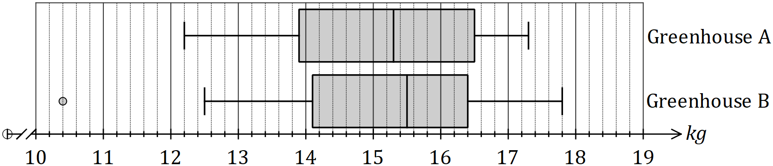

(a) Ignoring the outlier, compare the range of weights produced by plants in greenhouse $A$ with that of greenhouse $B$. (2 marks)

(b) State and use the interquartile ranges to compare the spread of weights produced by plants in greenhouse $A$ with that of greenhouse $B$. (2 marks)

(c) Given outliers are defined as values, ‘more than 1.5 x Interquartile range from the nearest quartile,’ use the result to, explain why one of the weights in greenhouse $B$ was identified as an outlier. (2 marks)

(d) Explain whether there is evidence to support the conjecture that the system in one greenhouse produces a larger crop of tomatoes than the other. (2 marks)

Question 4 (7 marks)

The overtime hours worked last week by some factory workers are shown in the table below.

|  |  |  |  |  |  |  |
| --- | --- | --- | --- | --- | --- | --- |
| Hours (*x*) | 0 | 1 | 2 | 3 | 4 | 5 |
| Workers (*f*) | 4 | 4 | 6 | 8 | 3 | 9 |

(a) Determine, for the number of hours overtime worked:

(i) the mean. (1 mark)

(ii) the median. (1 mark)

(iii) the standard deviation. (1 mark)

(b) How many workers had their hours recorded? (1 mark)

Another worker worked eight hours of overtime that week, but did not have the hours recorded.

(c) If those hours were included with the rest, how would this affect each of the answers to (a)?

Your answers will be “increase”, “decrease” or “no change”. (3 marks)

Mean –

Median –

Standard Deviation –

Question 5 (4 marks)

Prices of artwork sold at auction are normally distributed with a mean of $15,000 and a standard deviation of $2,500.

(a) Determine the price which is two standard deviations above the mean. (1 mark)

(b) What is the lowest price that is one standard deviation from the mean? (1 mark)

(c) How many standard deviations from the mean is a price of $9,750? (2 marks)

Question 6 (9 marks)

As part of an investigation into youth fitness, a researcher collected the sit-and-reach (SR) measurements of $250$ students. The data is summarised in the table below.

|  |  |
| --- | --- |
| SR measurement (cm) | Number of students |
| $$18<x≤22$$ | $$5$$ |
| $$22<x≤26$$ | $$10$$ |
| $$26<x≤30$$ | $$32$$ |
| $$30<x≤34$$ | $$68$$ |
| $$34<x≤38$$ | $$90$$ |
| $$38<x≤42$$ | $$36$$ |
| $$42<x≤46$$ | $$9$$ |

(a) Use the mid-point of each class interval to determine the mean and standard deviation of the sit-and-reach measurements. (2 marks)

(b) Explain why it was necessary to use the mid-point of each class interval to determine the statistics in (a). (1 mark)

(c) Draw a histogram on the axes below to display the distribution of SR measurements.

(3 marks)

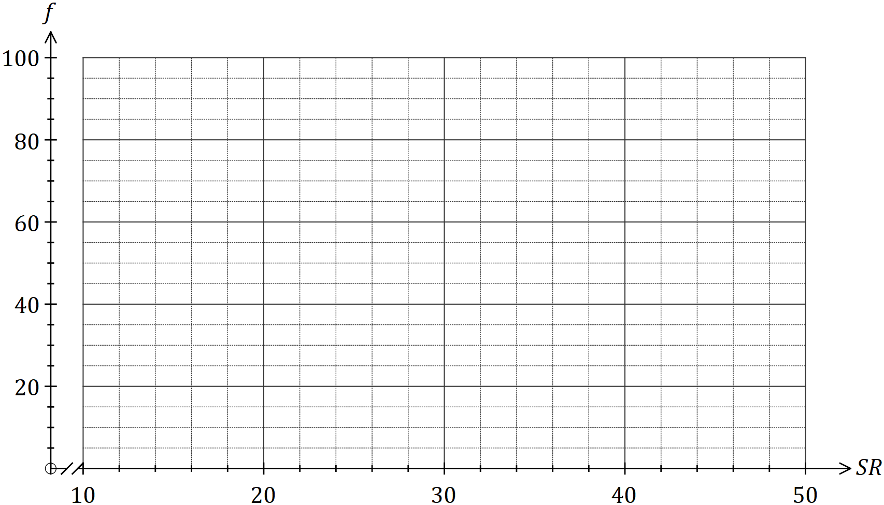

(d) Use features of the histogram to describe the distribution of SR measurements for this group of students. (3 marks)

Question 7 (6 marks)

The following bell-shaped curve shows the speed of cars in km/h on a road. Using the 68.3%, 95.4%, 99.7% rule answer the following questions:

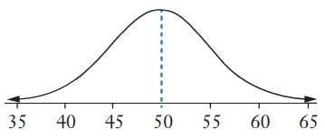

(a) What is the mean and standard deviation shown on the graph? (2 marks)

(b) If a driver was travelling at 57 km/h, what would be his standardised score? (2 marks)

(c) Driving between 40 km/h and 50 km/h is recommended on this road, what is the probability a driver is driving within this limit? (2 marks)

**EXTRA WORKING PAGE:**

Question: ____________